Properties of (simple) Molecular Structures

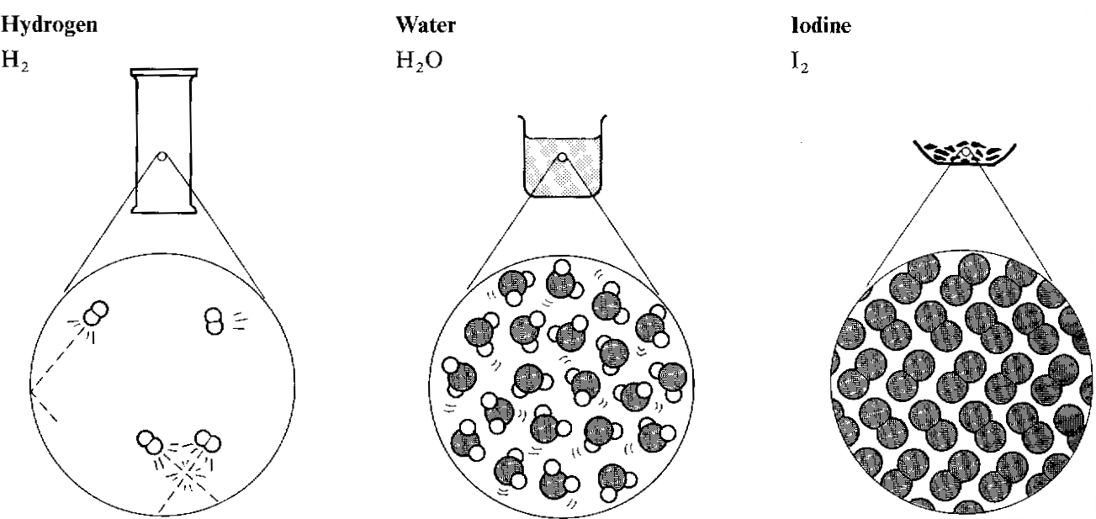

Weak intermolecular forces between molecules.

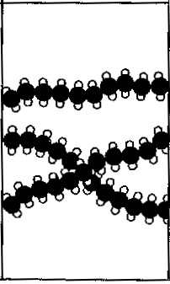
polyethene

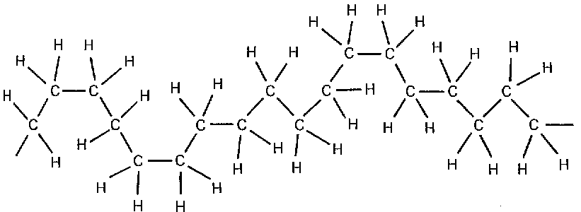
Or

Properties | Reasons
1. Low melting point  (gas or liquid at r.t.p) | The weak intermolecular forces are easily broken and molecules are therefore easily separated.  The forces between molecules are weak since the molecules are neutral.
2. Do not conduct | Covalent molecules are neutral so are NOT attracted to the power supply.
3. Insoluble in water | The neutral molecules are NOT attracted to the polar water molecules.  (Note: some polar covalent molecules such as HCl do dissolve in water since they react with the water.)

